Bilal Afreedi
SGISD Data Analysis Project

Completed creating the data in Excel.
Next step is to upload to python and begin cleaning.

Scale continuous Variables if needed, especially for predictive modeling
To do:
Clean
Change all country cells that are USA to United states
- Get rid of rows with null values and see how many rows you have after that
- Ensure variables like dates are correct for analysis
- Convert date columns to datetime and categorical data to categories
- Remove duplicates, like duplicate students with duplicate inquiry dates

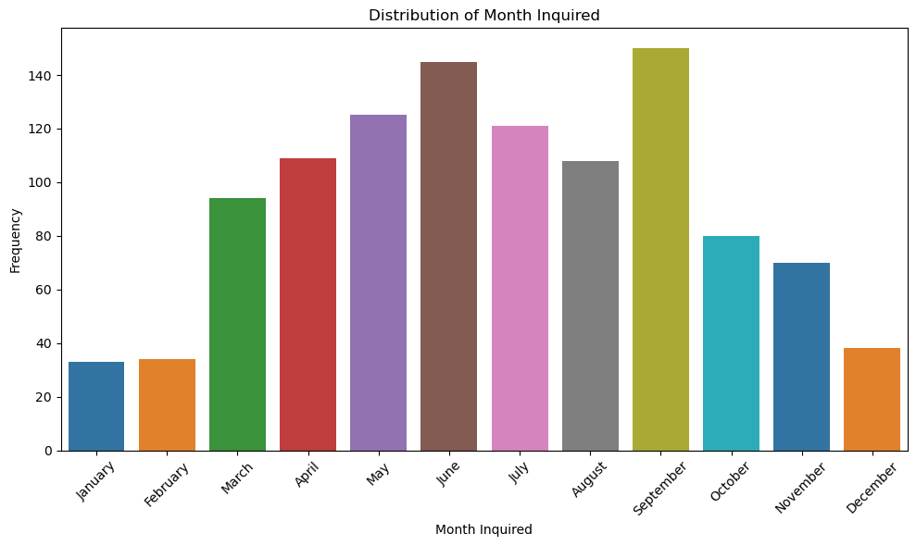

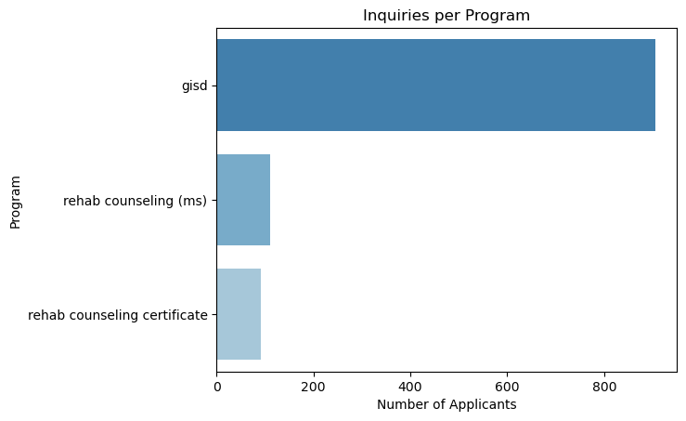
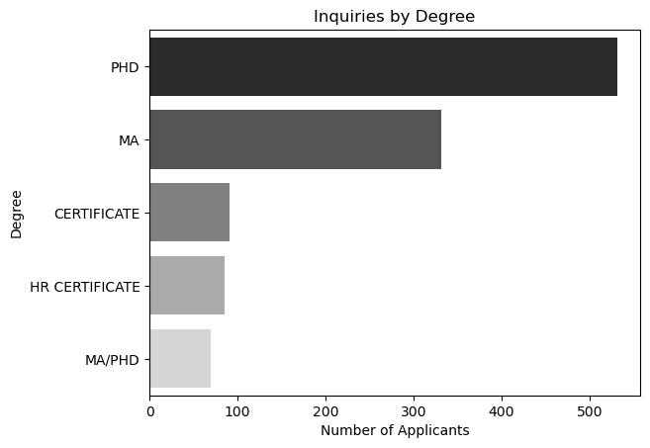

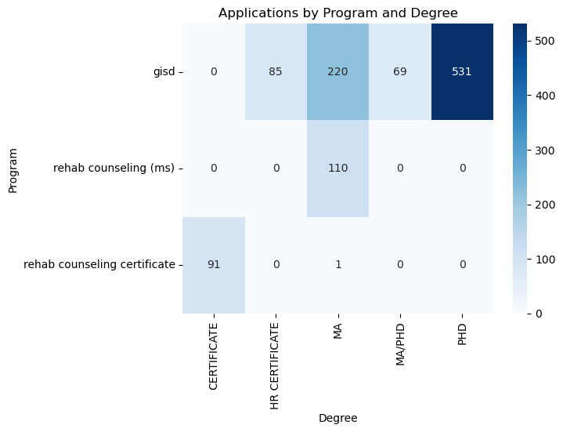
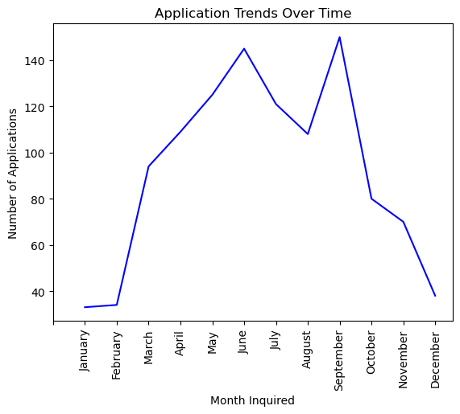
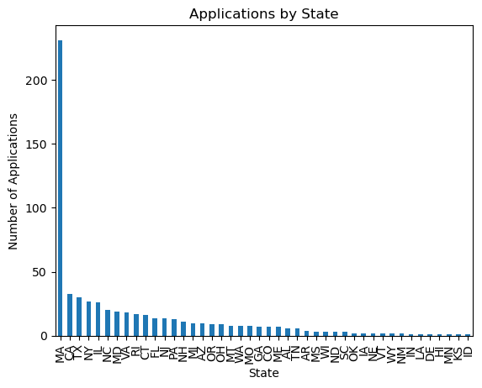

Null Hypothesis
States that there’s no effect or difference (e.g., “There is no difference in applicant numbers between programs”).

Alternative Hypothesis
Suggests that there is an affect or difference (e.g., “There is a difference in applicant numbers between different programs”).

What is a T-Test?
A statistic that is used to determine if there is a significant difference between the means of two groups and how they are related.
T-tests are used when the data sets follow a normal distribution and have unknown variances, like that data set recorded from flipping a coin 100 times.
Different kind of t-tests
1-sample t-test
Instead of a second population, your un a test to see if the average of your population is significantly different from a certain number or value.
Example: Is the average monthly spend among my customers significantly more or less than $50?

2-sample t-test
Where the means of two independent populations are compared to see if there is a significant difference.
Example: Do Californian shoppers spend more per store visit than Texan ones?

Paired t-test
With a paired t-test, you’re testing two dependent (paired) groups to see if they are significantly different. This can be useful for “before and after” scenarios.
Example: Did the average monthly spending per customer significantly increase after I ran my last marketing campaign?

You can also choose between one-tailed or two-tailed t-tests.
- Two-tailed t-tests tell you only whether or not the difference between the means is significant.
- One-tailed t-tests tell you which mean is the greater of the two.

When should you use a t-test?
A t-test is used when there are two or fewer groups.
More conditions for using a 2-sample t-test:
- Your data is expressed on an interval or ordinal scale (such as ranking or numerical scores)
- The two groups you’re comparing are independent of each other (one doesn’t affect the other). This one doesn’t apply if you’re doing a paired t-test.
- Your sample is random
- The distribution is normal (the results from a bell curve with the average in the middle)
- There is a similar amount of variance in each group (i.e. how far the data points are scattered from the average is similar for each group)
You also need to have a big enough sample size to make sure the results are sound
- However, one of the benefits of the t-test is that it allows you to work with relatively small quantities of data since it relies on the mean and variance of the sample, not the population as a whole.
In a t-test, the significance threshold is traditionally set at p = 0.05.
A p-value is basically the likelihood of finding a mean difference by chance if indeed there is no difference in the population.
The t-statistic is a value that represents the ratio of the difference between two group means to the variability (or standard error) of those differences.
- In the context of a t-test, it is used to determine if there is a statistically significant difference between the two group means.
- A positive t-statistic means the mean of the first group is higher than the means of the second group
- A negative t-statistic means the mean of the second group is higher than the mean of the first group.
- The higher the absolute value of the t-statistic indicates a larger difference between the means.

What is ANOVA (Analysis of Variance) Testing?
A test used to determine differences between research results from three or more unrelated samples or groups.
You might use ANOVA when you want to test a particular hypothesis between groups, determining – in using one-way ANOVA – the relationship between an independent variable and one quantitative variable.
Example: Examining how the level of employee training impacts customer satisfaction ratings. Here the independent variable is the level of employee training; the quantitative variable is customer satisfaction.
You would use ANOVA to help you understand how employees of different training levels – for example, beginner, intermediate and advanced – with the null hypothesis for the test being that they have the same customer satisfaction ratings. If there is a statistically significant result, it means the null hypothesis is rejected – meaning the employee groups performed differently.
The key word in ‘Analysis of Variance’ is the last one.
‘Variance’ represents the degree to which numerical values of a particular variable deviate from its overall mean. You could think of the dispersion of those values plotted on a graph, with the average being at the center of that graph. The variance provides a measure of how scattered the data points are from this central value.

How does ANOVA work?
ANOVA works by analyzing the levels of variance within more than two groups through samples taken from each of them.
In an ANOVA test you first examine the variance within each group defined by the independent variable – this variance is calculated using the values of the dependent variable within each of these groups. Then, you compare the variance within each group to the overall variance of the group means.
In general terms, a large difference in means combined with small variances within the groups signifies a greater difference between the groups. Here the independent variable significantly varies by dependent variable, and the null hypothesis is rejected.

Types of ANOVA
There are various approaches to using ANOVA for your data analysis.
One-way ANOVA
The simplest form – testing differences between three or more groups based on one independent variable.
Example: Comparing the sales performance of different stores in a retail chain.

Two-way ANOVA
Used when there are two independent variables.
Allows for the evaluation of the individual and joint effects of the variables.
Example: It could be used to understand the impact of both advertising spending and product placement on sales revenue.

Factorial ANOVA
This variant of ANOVA is used when there are more than two independent variables.
Example: A business might use factorial ANOVA to examine the combined effects of age, income, and education level on customer purchasing habits.

Chi Square Test
The chi-square test is a statistical procedure for determining the difference between observed and expected data.
This test can also be used to decide whether it correlates to our data’s categorical variables.
It helps to determine whether a difference between two categorical variables is due to chance or a relationship between them.
Evaluates if there’s a significant association between two categorical variables.
A low p-value (< 0.05) means that there is significant association between the two variables.

Chi-Square Statistic
This measures the discrepancy between the observed counts (actual data) and the expected counts.
A large chi-square value suggests a large difference between observed and expected values, indicating that there may be a relationship between the two variables.

p-value
This represents the probability of observing a shi-square statistic as extreme as the one calculated.
If the p-value is below a certain significance threshold (e.g., 0.05), we reject the null hypothesis (independence) and conclude there is an association between the two variables.

Degrees of Freedom (dof)
The degrees of freedom (dof) for chi-square test of independence is calculated as:
dof = (number of rows -1) x (number of columns – 1)
This number accounts for the number of categories in each variable and affects the critical value needed to reach statistical significance.

Expected Frequencies (expected)
The expected frequencies are the counts that would be expected if there were no association between the two groups.
Calculated based on marginal totals of the table.
Comparing these expected values with the actual counts helps the chi-square test determine if any observed discrepancies are due to chance.

Correlation Analysis
Correlation analysis measures the strength and direction of relationships between numeric variables, often visualized with a correlation matrix or heatmap.

Pearson Correlation (for linear relationships)
Measures the linear correlation between two continuous variables, ranging from -1 (strong negative) to 1 (strong positive).
Use case: Identify relationships between numeric columns
Interpretation: A high correlation coefficient (closer to -1 or 1) suggests a strong linear relationship
A linear relationship between two variables means that as one variable changes, the other variable tends to change at a constant rate.
- This relationship can be positive (both variable increases together) or negative (one variable increases as the other decreases)
In terms of correlation:
- Positive correlation (closer to +1) indicates that as one variable increases, the other tends to increase as well
- Negative correlation (closer to -1) indicates that as one variable increases, the other tends to decrease.
- No correlation (closer to 0) suggests no consistent linear relationship between the variables.

Extra Notes
groupby() – this pandas function is used to group rows in a DataFrame based on the unique values in one or more specified columns.
- Allows you to group your data and execute functions on these groups
Example use:
import pandas as pd
df = pd.DataFrame({'A': [1, 1, 2, 2], 'B': [3, 4, 5, 6]})
# Group by column 'A'
grouped = df.groupby('A')
# Calculate the sum for each group
result = grouped.sum()
print(result)

.size() – a function that counts the number of occurrences (rows) in each group.
- When used with groupby(), it provides the count of rows in each group.

